Chapter 13, Problem 41.

Determine I₁ and I₂ in the circuit of Fig. 13.105.

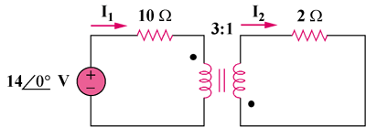

Figure 13.106
For Prob. 13.41.

